
Student and Parent Guide to
LSUE Dual Enrollment and the Academy
Fall 2026

Table of Contents:
Vision and Mission | 3
Dual Enrollment and Academy Classification | 4
Important Contact Info | 5
Important Webpages at LSUE | 6
Applying to LSUE Dual Enrollment | 7
DE and Academy Application Checklist | 8
DE Eligibility | 9
Scheduling an Accuplacer Exam | 10-11
Completing Online DE application | 12-14
Scheduling DE Courses | 15
Transferability of LSUE Courses | 16
Course Credit – CLEP, AP, or ACT | 17
Disability Accommodations | 18
Tuition | 19-20
I Clicker Attendance | 21
Bookstore and Textbook Purchase | 22-23
Parking and Driving on Campus | 24-25
LSUE DE Orientation | 26
Online Learning | 27-28
Tutoring Services | 29
Bengal ID | 30-31
Transfer Course Agreements,  Grade Appeal, HS Ranking, Sports and DE | 32
Withdrawing from an LSUE DE course | 33
Long Term Impacts of Withdrawing | 34
DE Midterm Grades | 35
DE Final Grades | 36
I-Grade Request | 37
Requesting Official LSUE Transcript | 38
100% Online LSUE Associate Degrees | 39
Requirements for Associate Degree | 39
Reverse Transfer | 40-41
Applying for LSUE Graduation | 42
Sexual Misconduct and Title IX | 43
Mental Health Counseling Services | 44
Academic Integrity Statement | 45-46

LSUE Academy and Dual Enrollment Vision

The LSUE Academy and Dual Enrollment exist to provide high school students with an early start in their post-secondary education.

LSUE Academy and Dual Enrollment Mission
The LSUE Academy and Dual Enrollment exists to partner with local high schools to provide high school students with an opportunity to earn an associate degree before high school graduation that embeds career development activities and enhances students’ career readiness skills.

DUAL ENROLLMENT
Dual Enrollment allows high school students to take college courses and receive college credit while in high school through a variety of methods:
- With a qualified high school teacher on their school campus
- Through LSUE by enrolling in an online course that is facilitated on the high school campus
- In a face-to-face setting on the LSUE campus
The college credits can be used simultaneously for a high school diploma and a college degree or certificate.

LSUE ACADEMY
The LSUE Academy is an innovative approach to secondary education that enables high school students to potentially earn an associate degree while earning their high school diploma by taking dual enrollment courses. Academy students will take dual enrollment courses that will simultaneously earning them credit towards their high school diploma and fulfill course requirements for a chosen degree path. To be a part of the Academy students should:
- Begin coursework as a high school junior.
- Be considered a full-time student based on credit hours they are carrying, for a minimum of four semesters.
- Declare a major and follow that degree plan.

BENEFITS OF Dual Enrollment and the ACADEMY
- Saves families money. – LSUE offers DE courses at a lower rate per credit hour than regular admission students pay.
- Earn college credit that is transferable to all Louisiana public colleges and universities, and most other private and out of state colleges and universities.
- Explore potential college majors and learn more about the college experience.
- Grades earned become a permanent part of the student's high school and college transcript.
- Enriches college and scholarship applications.
- Students gain confidence in their ability to succeed in college.
Important Contact Information

Director of Academy
Office # - 337-457-6130
Email – afonten1@lsue.edu

Financial Aid Office
Office # - 337-550-1282
Email – finaid@lsue.edu

Tutoring Services
Office # - 337-550-1206
Email – tutoring@lsue.edu

Disability Services
Office # - 337-550-1206
Email – ods@lsue.edu

Admissions (Geaux Center)
Office # - 337-550-1329
Email – admissions@lsue.edu

Information Technology
Office# - 337-550-1307
Email – it@lsue.edu

Bookstore (Geaux Center)
Office # - 337-550-1281

Registrar (Geaux Center)
Office # - 337-550-1302
Email – registrar@lsue.edu

Business Office (Science Building)
Office # - 337-550-1262
Email – businessaffairs@lsue.edu

Student Affairs (Acadian Center)
Office # - 337-550-1218
Email – stuaff@lsue.edu

Library (Arnold Ledoux Library)
Office # - 337-550-1380
Email – library@lsue.edu

Important Webpages at LSUE

LSUE Resources:

Final Exam Schedule - www.lsue.edu/exams
Academic Calendar – www.lsue.edu/calendar
Transcript request – www.lsue.edu/transcript

Course Resources:

Workday Student - www.myworkday.com/lsu
myCourses – http://mycourses.lsue.edu/

Tutoring Resources:

LSUE Library - https://www.lsue.edu/tutoring-center/index.php
- Peer tutoring
- Online tutoring – NetTutor
- Faculty tutoring

LSUE Enrollment After High School Graduation

LSUE Tour – https:// lsue.edu/tours
LSUE Admissions – https://www.lsue.edu/admissions/index.php
LSUE Scholarships - https://www.lsue.edu/financialaid/scholarships.php
Admissions Email – admissions@lsue.edu

Applying for LSUE Academy or Dual Enrollment

- Students should meet with their high school counselor and express interest in Dual Enrollment.
  - The counselor should determine if student meets eligibility requirements for Dual Enrollment (see eligibility requirements section) and discuss with student options for qualifying for Dual Enrollment (upcoming LEAP2025 exams, Scheduling Accuplacer Exam or ACT).
  - Counselors will provide LSUE Dual Enrollment office with a copy of test scores and high school transcript – students do NOT need to upload those items.
- If eligible, students should decide where they would like to take their DE courses:
  - High school
  - Online only
  - LSUE Campus
  - Combination
- New DE/Academy students should complete LSUE online DE application following the instructions provided by their counselor and in this manual. Returning students will complete a DE Renewal form.
- Once admitted, students will receive an Admission notification by email.
- Dual Enrollment students should meet with their school counselor to schedule DE courses. Academy students will schedule advising meetings with an Academy advisor and then will bring Course Registration forms to their school counselor for approval.

DE and Academy Application Checklist
Prior to Applying
- Meet with your school counselor to determine eligibility and best option (Academy or DE)
Applying for Admission
- Complete the online application for Dual Enrollment or the Academy based on counselor recommendation.
- Receive application submission confirmation email from LSUE Admissions
After Admission to DE/Academy
- Receive acceptance email from LSUE OIT
- Setup your LSUE accounts following directions in Workday emails
- Complete online LSUE DE Orientation (Academy and DE students)
- Complete Immunization form – required for on campus students
- Take LSUE ID picture – required for on campus students – DE students are encouraged to get an ID
- Buy a parking permit – required for on campus driving students only.
Registering for Courses
- Meet with your counselor if DE or an Academy advisor if you are an Academy student to complete a course registration form.
- Pay tuition (if applicable, check with your counselor)
- Review each course syllabi on myCourses
- Purchase/Rent required textbooks.
- Check your LSUE email DAILY!

LSUE DE and Academy Eligibility Guidelines:
2026-2027

Eligibility based on Standardized Tests Scores:
- Engl II LEAP 2025 – Mastery or Advanced – May enroll in English, History, sociology, psychology, and Art courses
- Geometry LEAP 2025 – Mastery or Advanced and Alg II C or better – May enroll in Math or Science courses.
- Both Engl II and Geometry LEAP 2025 – Mastery or Advanced on both exams and Alg II C or better – all DE course, except where otherwise noted.
- ACT Math score of 19 and ENGL II LEAP 2025 Mastery or advanced – any DE course, except where otherwise noted.
- ACT English score of 18 and Geometry LEAP 2025 -Mastery or Advanced on LEAP 2025 Geometry and Alg II C or better – any DE course, except where otherwise noted.
- ACT Math 19 and English 18 – Any DE course, except where otherwise noted.
To be eligible to enroll in the LSUE Academy a student must be eligible to enroll in both Liberal Arts and Math/Science coursework. DE students can be enrolled with only one area of eligibility.
Some parishes/schools have higher guidelines, students should confirm with their school counselor if they are eligible.
To be eligible to qualify for all courses students may take an Accuplacer Exam (except where otherwise noted):
- ACT Math 19 or Geometry LEAP 2025 Advanced or Mastery but no English qualifying score – take Accuplacer English (Writing exam only) - score 250 or higher.
- ACT English 18 or English II LEAP 2025 Mastery or Advanced but no qualifying Math score – take Accuplacer Math exam (QRAS exam only) – score 250 or higher.
- Counselor Recommendation – Counselor must complete LSUE Counselor Recommendation form and must justify recommendation based on previous performance in equal academic courses as requested for DE. (Not every parish will allow this option)
Instructions for DE and Academy students to schedule an Accuplacer Test in the LSUE Testing Center:

Go to the LSUE Testing Center Website http://www.lsue.edu/testing-center/ at least 24 hours in advance to schedule.
Note: Your FIRST attempt on the ACCUPLACER Assessment is free, but you must pay for additional attempts.

Under “TESTING” choose “SCHEDULE AN EXAM”
This will bring you to the RegisterBlast Website where you will choose:
1. Choose a Group: LSUE Student
2. Choose a Group: ACCUPLACER
3. Choose a Group: FIRST Attempt or Additional Attempts
4. Choose an Exam: Select from 7 options (Math, Reading, English, or a combination of these)
5. Date (only available days will be displayed)
6. Time (only available times will be displayed)
7. Name, Email
8. Agree to the Exam Guideline Acknowledgement
9. Phone Number, LSUE Student ID

Note: If you do not have an LSUE Student ID yet, please use a capital “D” followed by the last 4 digits of your social security number for your student id number.

ADD TO CART
You will now have the option to Check Out or Schedule another exam.
Pricing for LSUE Student for Additional ACCUPLACER attempts is as follows: (pricing subject to change)
1 test $20
2 test $30
3 tests $35
Next-Generation sample questions in Quantitative Reasoning, Algebra, and Statistics (Math), Reading, and Writing (English) can be found at: https://accuplacer.collegeboard.org/student/practice
In addition, the College Board has developed the Web-Based Study App. It’s available for free at https://accuplacerpractice.collegeboard.org
Be sure to use the “Next-Generation Questions” and not the Classic.

Steps for Completing Online Application for
LSUE Dual Enrollment
Fall 2025 and Beyond

- Go to www.lsue.edu
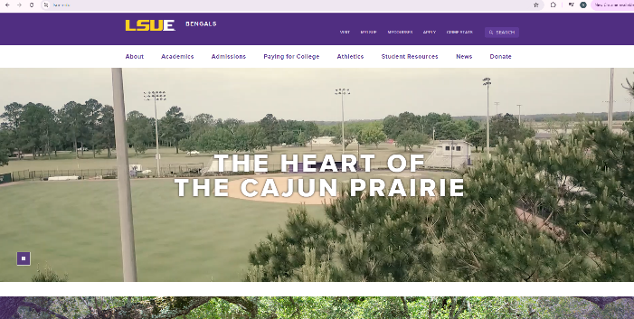

- On the top of the home page, click Apply.

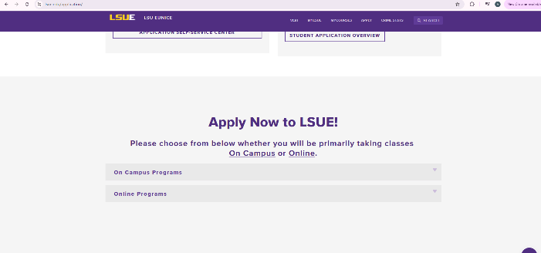
- Scroll down until you see Apply Now to LSUE – Click On Campus (even if you only take online courses).
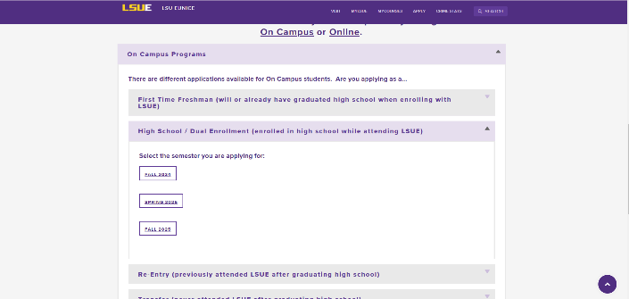
- Click the drop down arrow for High School/Dual Enrollment (enrolled in high school while attending LSUE)
- Click the semester that you are applying for
- Start your application by clicking the button “Start my New Application” 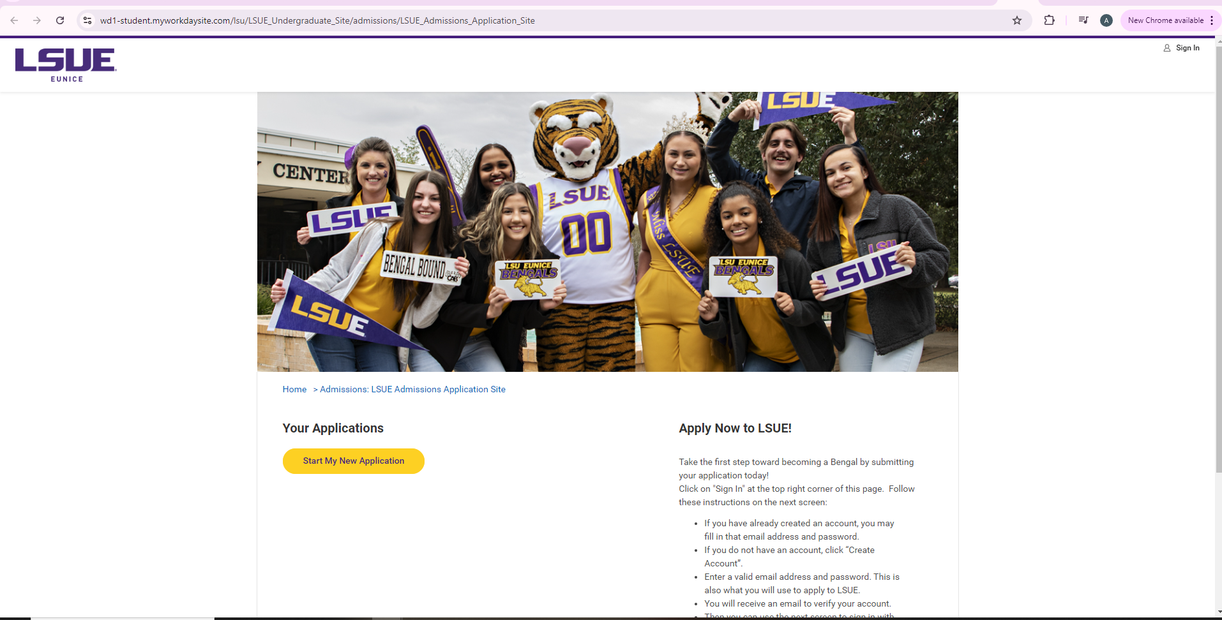
- Create your account (Write down your username and password and save it – this will be needed later – DO NOT use your high school email address)
- Verify your email address using the email sent to your personal email address.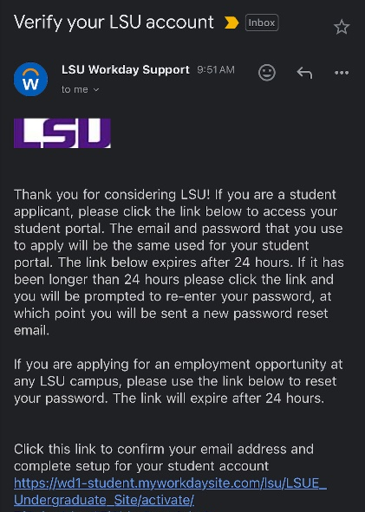
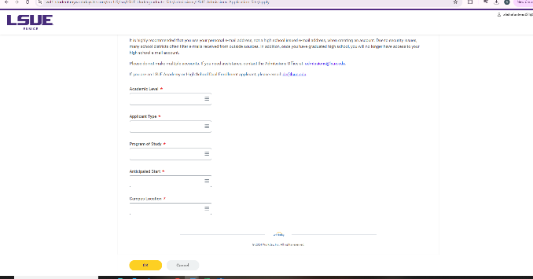
- Log into the application portal with the email address and password you set and verified with the email that was sent to you.
- Start application
- Academic Level – Undergraduate
- Applicant type –
  - LSUE- Academy for High School students (for those students trying to earn a degree)
  - LSUE – High School Dual Enrollment (for non degree seeking high school students)

- Choose your program of study.
  - Academy- what you think you will major in after high school – this can be changed later on if you need to.
  - Dual Enrollment – Choose High School Dual Enrolled Students
- Anticapated Start Date – choose the semester you plan to begin
- Campus Location – LSU Eunice
- Application Overview – Fill in each section of the application – You can go back and make corrections by clicking the Edit tab on that section after you have finished it.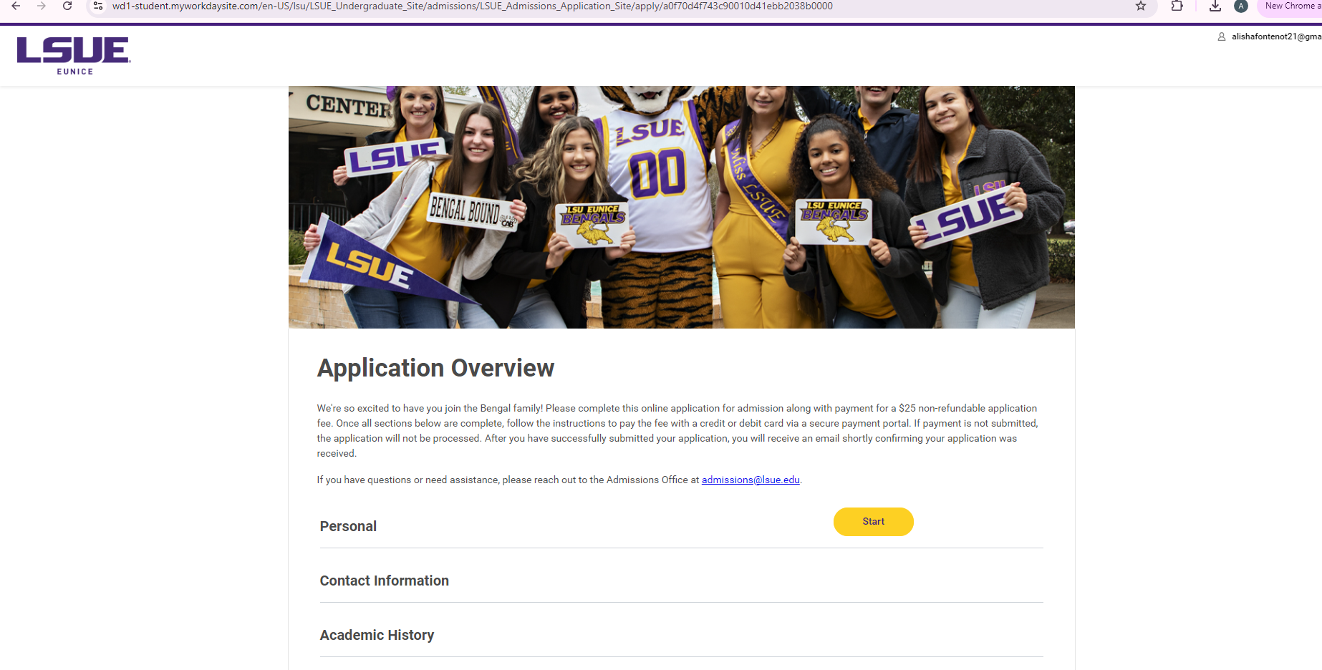
- Academic History
  - High School Education – country should stay as United States, region is Louisiana, put the city your school is in to limit the choices of schools that pop up under institution name.
  - Graduation Status – Did not graduate
- Student Certification – mark yes after you have read the certification
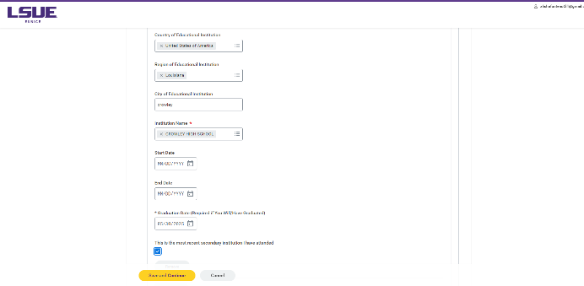
- Application Fee – This does NOT apply to DE/Academy students – DO NOT pay the fee – just certify and submit your application

Scheduling Dual Enrollment Courses

- Dual Enrollment students will meet with their school counselor to schedule their DE courses. Academy students will schedule advising meetings with the Director of Dual Enrollment and bring Course Registration forms to school counselors for approval.
- Below is a chart of common DE courses by semester – this is not the only classes available to DE students.
- Students may take any LSUE course that they qualify for
- All high school students can take summer semester DE courses at the Dual Enrollment tuition rate. The Dual Enrollment office will schedule all students for summer session.

Fall | Spring
MATH 1020/1021 | MATH1022
ENGL1001 | ENGL1002
ENGL1002 | HIST1003
HIST1001 | HIST2057
HIST2055 | ART 1441
ART 1440 | ENGL LITERATURE (VARIES)

Transferability of LSUE Courses

LSUE Course Transfer Guide – LSUE Transfer Evaluation System
https://www.lsue.edu/registrar/course-transfer.php

Louisiana Board of Regents Course Transfer Guide - Articulation and Transfer – Louisiana Board of Regents
https://regents.la.gov/articulationandtransfer/

Earning Course Credit from CLEP Exam, AP Exam, or ACT Test

Instructions for receiving course credit from Standardized Exams:
- Complete a Course Credit form (download the form online from the DE website and email the form to the Director of Dual Enrollment at LSUE.
- The Dean’s office and/or the Director of Dual Enrollment will acquire the necessary signatures on the form.
- The Dean will forward the form to the Business Office who will contact the student through the student’s LSUE email requesting payment for the credit.
- Once the student pays for the course credit, the Business Office will send the form to Admissions requesting that the Registrar’s Office place the credit on student’s transcript.

- Click here for link to online Credit Form (https://www.lsue.edu/registrar/documents/Credit%20Form.pdf)

- Link to list of CLEP Exams/AP Exams and LSUE Course credit earned (Academic Catalog – Campus Regulations – Advanced Standing Program) (http://catalog.lsue.edu/content.php?catoid=16&navoid=856)

  - Scroll down the page to the Advanced-Standing Program section.

HOW TO APPLY FOR DISABILITY ACCOMODATIONS

*** Note – High School 504 plans and IEP accommodations do not follow a DE student to college and do not automatically apply to a Dual Enrollment course. A student must submit an application for Disability Accommodations to the Office of Disability Services.

- Go to www.lsue.edu. Select Students and then select Student Success Center
- Under Student Support Services select Disability Accommodations.
- Select the form required for your disability (ADHD, Learning Disability, Physical and Systemic Disability, Psychological Disability).
- Print the form.
- Complete, sign, and date the Request for Accommodations section of the form.
- Submit the completed Request for Accommodations form to the Office of Disability Services
- Complete the top half of the Documentation Request form for the qualified professional who is treating your disability.
- Provide the qualified professional with the remaining pages of the downloaded disability paperwork. The qualified professional must complete and submit this paperwork directly to Disability Services, along with any supporting documentation.
- Disability Services will email you to set up a meeting once they receive and review all documentation. Check your LSUE email often.
- If approved, you will receive an accommodation letter for your professors.
- You must provide a copy of this letter to each of your professors. (Disability Services will not alert your professors of your accommodations for you.)
- Note – You must submit a copy of the Request for Accommodations each semester in order to continue receiving your accommodations. Submit pg. 3 only of the form Request for Accommodations to the Office of Disability Services each semester for renewal.
Tuition
Cost of Courses
Beginning with the Fall 2023 semester, all Dual Enrollment tuition will be $100 a course credit regardless of whether the course is taken on the high school campus, the LSUE campus, or online (the $50 per course online fee still applies to online courses). This price is subject to change.

Tuition Fee Payment
Some districts cover the cost of tuition and may cover the cost of textbooks. You DO NOT have to pay any tuition to LSUE. You MAY have to pay for your Bengal Access textbooks.
Payment of tuition and fees can be made by one of the following methods:
- Workday Student - Pay in a lump sum online via PayPal with one of the flowing: VISA, MasterCard, Discover, American Express, or echeck
- Payment Plan – Enroll in the payment program. This plan allows you to have your balance owed to the University put into monthly payment based upon your time of enrollment in the program.
- Check or money order – Mail your check or money order to the Business Office or pay in person.
Bengal Access textbook charges will appear on the fee statement by midterm. If districts do not pay for textbooks students must pay the textbook charges using one of the methods above.
The Business Office is chiefly responsible for ensuring that students make arrangements to either (a) clear their fees with financial aid money or (b) pay their fees by the deadlines established in the Academic Calendar and the Registration Guide. Students who have questions about charges on their student accounts or questions about fee payment should contact the Business Office.
Important Terms and Definitions
Course and Fee Statement – A document that contains a class schedule, tuition charges, and financial aid award information. Students should receive a hard copy of this document after meeting with an Academic Advisor who helps to schedule your classes.
Financially Cleared (or Clearing of Fees) – Refers to the financial status of a student who must have a zero balance or a credit balance on his/her Workday Student account.
Payment Plan – A payment plan is offered to students to cover the cost of the charges to their account and/or personal funding to pay the balance of the account. Students have the option to sign up for the payment plan before the start of the semester. The payment plan allows students to pay monthly amounts toward the balance owed to the University.
Purge – The process by which students that have not financially cleared their tuition/ fees by the payment deadline will result in the student being dropped from the class rolls.

Business Affairs
P.O. Box 1129
Science Building, Room 101
Eunice, LA 70535
Phone: 337-550-1262

I-Clicker Attendance Policy

There is a direct correlation between student attendance in college courses and student success in these courses. LSUE Dual Enrollment strives to improve our efforts in ensuring all our students receive the best support and education possible from LSUE.
To better monitor high school student attendance in their LSUE campus classes, Academy students are required to sign in daily at LSUE. All LSUE Academy or DE students taking classes on the LSUE campus will be required to be on campus on the days they are scheduled for classes at LSUE. Academy students will be required to sign in daily using the I Clicker on their phone or laptop. The app is location sensitive and will require students to have their location services on and be within 500 feet of the LSUE clock in the center of the campus in order to check-in for attendance.
Failure to activate an account by the start of the semester will result in referral to your school administration for consideration for removal from the LSUE Academy.
Please follow the instructions you receive in an email to set up your I Clicker account. You can also download the iClicker app to your smart phone once you have your account set up. You must turn on your location services on your phone for this app. You can check in from the library, Science building, Manuel Hall, by Starbucks, at the end of Community Education closest to the statue by the quad, or anywhere within the quad. Instructions are included in the email on how to check in daily. Search for LSUE Academy.
Any time you will not be in attendance for your classes at LSUE or an instructor cancels class, you are required to email me. Once a student reaches 5 unexcused absences for the semester, the high school will be notified of the student’s absences and the student will not be allowed to return to the LSUE Academy the following semester. Attendance begins the first day of the semester.

Bookstore and Textbook Purchases
Bookstore Hours
Monday – Friday
7:45 am – 4:30 pm
Phone: 337-550-1281

Students need to read the course syllabus to determine required textbooks for each course.

Purchasing Textbooks

If your district covers the cost of textbooks, you must purchase the textbook in the LSUE Bookstore and use Bengal Access when available.

Bengal Access Program
What is Bengal Access?
Bengal Access is a program that provides students with required textbooks and other course materials in a digital format at a reduced cost, that is available to them on the first day of class through MyCourses.
How do I access these digital course materials?
The course materials will appear as a link in your My Courses. You click on the class that you want to access the materials. There will be a tab in Mycourses that says “Redshelf External Tool.” You must click on this tab, and the next tab will say access my course materials. Click on this, and you will either be provided with a link to an e-text, or an access code that will be used for a courseware product (i.e., MyMath Lab, Mastering Biology or Chemistry, etc.) If you do not see the Redshelf external tool, please contact your instructor asap or contact us at the bookstore.

How do I use the Access code for my class?
If you are taking a math class, or any science class that requires you to have access to Mastering, or Connect, please first follow the link provided by your instructor for the class. This will send you to the courseware website. If you have not already, set up an account (if you clicked on the link provided by the instructor, it will automatically have the course key embedded, so you will not have to enter it. After you complete your registration, you will be asked to either enter a code, or purchase a code. Please refer to the Redshelf External tool. The code you receive when you click on access course materials is the access code you need to complete your registration.
Make sure your Pop-up Blocker is disabled.
When and how will I be billed for these course materials?
Students will not be billed until after the 14th class day. You will receive an email from the bookstore stating what you were charged for once these charges post. Please watch your email box.
Issues with Redshelf
For tech support or issues with codes, or with digital text, please go to https://solve.redshelf.com/hc/en-us. If there is not a solution to your issues, you can fill out a trouble ticket and get it resolved.

Parking and Driving on the LSUE Campus

Parking Permit
All students taking courses on the LSUE Campus must register their vehicle with LSUE and purchase a parking decal.

Registering Your Vehicle
To park and operate a motor vehicle on campus, students must register their vehicles on the LSUE website. Students are held responsible for knowing and obeying campus traffic regulations, which are outlined below.

Paying for and Receiving your Parking Permit
After you have registered your vehicle online you must make a payment of $60 in person at the Business Office. The Business Affairs Office is open 8:00am – 4:30pm, Monday through Friday and is located in the Science building.
Once you have registered and paid you will be given your permit/decal. Make sure to put the decal on the bottom left-hand corner of your rear windshield immediately to avoid receiving a parking citation.

Traffic and Parking Regulations
Parking decals must be placed on the left of the rear windshield affixed on the outside of the glass. Pedestrians always have the right of way on campus streets and parking areas. Unless a different limit is posted, the speed limit is 15 mph on all campus streets and 10 mph in parking areas. Vehicles must be centered in marked parking spaces and must not be backed into parking spaces. Backing into a space or pulling across to an opposite space leaves the parked vehicle illegally facing against the flow of traffic and prevents Police and Security Officers from being able to easily read decals. Vehicles must be registered by the end of the first full week of classes with decals that are valid from the date the car is registered until the following August. Vehicles must follow established traffic routes, stop at all stop signs, and obey all other traffic regulations. Vehicles must be parked in spaces designated specifically for the associated parking permit. Vehicles improperly parked in faculty/staff spaces, designated handicapped spaces, loading zones, fire lanes, or other improper spaces will be ticketed and/or towed at the owner’s expense. Parking and traffic tickets may be appealed in the Office of Student Affairs.
LSUE DE Orientation
All first-time dual enrollment students are required to complete an online DE orientation.
The LSUE DE orientation link will be emailed to all students. The link will redirect the student to the LSUE DE online orientation on the student’s MyCourses page.
Through the online orientation process, students will learn very important topics such as:
- How to log onto your Workday
- Set up your LSUE email
- How to navigate your learning platform (MyCourses) – especially useful for online courses
- Tutoring
- Library services
- Plagiarism and student conduct
- Advising and registering for courses
- How to pay tuition
- Adding and dropping courses
- LSUE academic calendar

Online Learning

About LSUE Online Learning
LSUE is committed to providing the same quality of education and support to online courses and online degree programs as is provided to face-to-face courses and programs. This includes the same quality of course content, faculty instruction, and access to resources, including IT support, library resources/databases, financial aid, tutoring, disability accommodations, academic advising, and more.
View the “Academic Programs of Study” section of this handbook to see which programs are offered 100% online to learn how you can earn a degree or certificate without having to step onto the Eunice campus.
MyCourses
MyCourses (also called “Moodle”) is the online platform that hosts all of the courses that you will take as an online student, including syllabi, assignments, grades, instructor contact information, forums, and more. To access MyCourses, go to www.lsue.edu/ and click on “MyCourses” on the top left. Then, enter your LSUE login credentials, and click “Log in.” You can also access MyCourses through your Workday account.
About ProctorU
Identity verification services and exam proctoring for online courses are provided by ProctorU. Students should expect to pay individual fees per exam. Exact charges will vary depending on the length and number of proctored exams per course. Specifics on the number and length of proctored exams in a course will be available in the course syllabus.
Online Conduct
All students are expected to read the Code of Student Conduct. However, students enrolled in online classes should become very familiar with the academic misconduct section of the Code of Student Conduct section, particularly the violations that frequently occur online, such as theft, disrespect, and dishonesty. In short, do not cheat; make sure your work is your own; and be respectful and courteous when communicating with your online classmates and your instructor. Reference the Code of Student Conduct for more information on prohibited conduct and possible sanctions that could result if found responsible.

Tutoring Services

The Student Success Center offers free peer-to-peer tutoring services to all LSUE students in the Tutoring Center. This includes assistance with homework assignments, academic support, supplemental instruction, and more. For more information about online or face-to-face tutoring services, contact the Student Success Center.
Face-to-Face Tutoring
Common subjects for which students seek tutoring include, but are not limited to, the following:
θ English/writing assistance
θ Math
θ Biology
θ Chemistry
θ Psychology

Online Tutoring

NetTutor is the online platform used by LSUE. It provides 24/7 tutoring for a variety of subjects.

Tutoring Center
Ledoux Library, Room 102
Phone: 337-550-1254
Email: tutoring@lsue.edu
https://www.lsue.edu/studentsuccess/tutoring.php

Bengal-ID: Your Passport to Campus Services
What is a Bengal-ID?
Bengal-ID was created to provide students, faculty, and staff with a fast, safe and convenient way to access campus services. While serving as the official university ID card, it is also a debit card for campus purchases as well as an electronic key for secure access to selected campus facilities.
What is Bengal Bux?
Bengal Bux is a debit card system using your Bengal-ID Campus Card to provide a fast, safe and convenient way to make purchases at various locations throughout the campus. As long as you have money in your Bengal Bux account, you’ll enjoy convenient purchasing power without the hassle of carrying cash. Value may be added to your Bengal-ID at any time using Value Transfer Stations conveniently located in both the Acadian Center and the Library. Known as Bengal Bux, card value can be used throughout the campus for a variety of uses such as cafeteria purchases, selected vending machines, and making copies and printing in campus computing labs once your initial free print allowance has been used.
Getting Your Bengal-ID Card
All LSU Eunice faculty, staff and students are required to have a BENGAL-ID campus card. As the official ID card of the campus, your BENGAL-ID card should be carried at all times. Campus offices may require you show your card before receiving services.
The Bengal-ID Office is a unit within the Office of Information Technology located in room 204 of the Community Education Building. Regular office hours are between 8:00 a.m. and 4:30 p.m.
There is no charge to receive your first card. Card holders will be charged $5 to replace lost or misplaced cards. Card privileges for students will not become active until your tuition and fees for the semester are paid.

Why Do You Need It?
As the official id card of LSU Eunice, it provides you with admission to campus events such as athletics and fine arts presentations.
- It’s required to make copies on campus.
- You must have your BENGAL-ID to use the printers in campus computer labs.
- It’s required to use campus recreational facilities including the gym, weight room, and pool.
- Many area merchants provide discounts to LSU Eunice students and employees. You must present your BENGAL-ID to take advantage of these services.
- Use the BENGAL-ID in in the cafeteria and at other campus locations instead of carrying cash!

Grade Appeal Procedure

If you believe you received a different grade than the grade earned as outlined by the grading system in the course syllabus and the established grading system, you can file an appeal of that final grade. Grade appeals must be initiated by the student within 30 days after the beginning of the next regular semester. For support and guidance on how to file a grade appeal, contact the Office of Student Affairs

Ranking in High School

Each district has its own policies on ranking so please check with your district.

Sports and Dual Enrollment

LHSAA Basic Eligibility Guidelines – https://www.lhsaa.org/students-parents
Students should check each semester with their coach to ensure full eligibility requirements are being met.

Withdrawing from LSUE DE Courses

- Prior to the 1st day of classes, a counselor or student may drop a course by emailing the Director of Dual Enrollment. Emails must come from a counselor’s school email address or from a student’s LSUE email address.
- After the first day of class until the final date to withdraw with a “W” (see Academic Calendar), a student may withdraw from a course using a DE Course Withdrawal or Resignation Request form.
- Students can request exceptions to these policies by completing an Exception to University Policy form (completed online using the instructions below):
  - Instructions for completing Exception to University Policy Form (see form link below):
    - Request for: (semester enrolled)
    - Division: Undecided
    - I request to: Drop a class after the last day to withdraw.
In the first box:
    - Drop (List all course names wanting to drop), Credits 3, Section #
    - In the student narrative box: State reason why they are dropping classes after the deadline to drop or add.

Use this link for the Exception to University Policy form - https://www.lsue.edu/registrar/documents/exception-reg.pdf

Use this link for the Academic Calendar - https://www.lsue.edu/calendar/index.php

Dropping a Course Can Have Long Term Impacts for DE students

Standards of Academic Progress
To be eligible to participate in the Federal Student Aid Programs, a student must meet all the following minimum Standards of Academic Progress (SAP). The policy below applies to ALL students applying for financial aid.
STANDARDS
- 70% Rule
  - Students must earn a minimum of 70% of cumulative attempted hours (i.e., all attempted hours on the transcript regardless of grade received).
  - Attempted hours are defined as the hours for which a student is enrolled as of the last day to drop classes without a “W”.
*All courses on the transcript count toward the total attempted hours.

Ex. 1 - If they take 1 DE course and drop 1 course, they are at 0% completion.
Ex. 2 - If they take 2 DE courses, and drop 1 DE course, they are at 50% completion

****Dropping a DE course counts against the 70% rule and, if they go below 70%, a student is placed on Academic Probation with financial aid at whichever college they apply to after high school and WILL NOT be eligible for any financial aid (grants, loans, etc).

APPEAL PROCESS
A student who becomes ineligible for aid because they have failed to meet the standards will continue to be ineligible until they reestablish eligibility.

Students below 70% completion should be advised to submit a financial aid appeal with financial aid at the University they apply to after graduation.
Dual Enrollment Midterm Grades
Midterm Progress Report – DE and Academy
- Midterm grades for all courses taken by students will be reported to their school counselor within one week of the final midterm being administered.
- Grades will be reported as A, B, C, D, or F.
- Midterm grades are in progress grades and should not be used as 9-weeks grades.

Midterm Academic Intervention - Academy
- Any Academy student with a D or F in a course at midterm will be placed on academic intervention.
- A form will be sent to parents and counselors advising them of the unsatisfactory midterm grade.
- The student will be required to check in with the Director of the Academy on a weekly basis for the remainder of the semester to review current grades and progress in the class.

LSUE Academy/Dual Enrollment Final Grades
Final Grade Report
- Final grades for all courses taken by students at your school will be reported within one week of the last final exam being administered.
- Grades will be reported as A, B, C, D, or F.
- Counselors must record the students’ final grades in the district grading system for all DE courses according to district policy.
- Students can print unofficial transcripts to be placed in their cumulative folders.
- Official transcripts can be requested through the Registrar’s office for a fee.

Requirements for Continuing in the LSUE Academy/Dual Enrollment
To remain in the LSUE Academy/DE program the following semester, students must meet the following requirements:
- Students must have maintained a 2.5 High School GPA and college GPA.
- Students must have cleared all financial fees.
- Students must meet all district DE guidelines for continuing.
WHAT IF I HAVE EXTENUATING CIRCUMSTANCES AND CAN NOT COMPLETE THE SEMESTER BUT I AM PASSING A COURSE?

- Log onto www.lsue.edu. Select Academics and then select Registrar.
- Select the I Grade Request form.
- Complete the form.
- Submit the form and all supporting documentation (medical records, accident reports, legal documents, receipts) to the Vice Chancellor of Academic Affairs – M102D.
- The Vice Chancellor of Academic Affairs will review the documentation and make a determination.
- You will receive a letter stating the decision and your professors will receive a letter if it was determined that you will receive an “I” grade.

Important Information:
· You must have completed 75% of the course material in the course at the time of the request.
· Request must be made prior to the final examination date for the course(s) you are requesting an “I” grade.
· If approved, you must complete all missed work in the course before the last day to add classes the following semester. Failure to do so will result in an “F” in the course(s).
Link to I Grade request form - https://www.lsue.edu/registrar/documents/I%20Grade%20Request%20Form.pdf

Requesting an Official College Transcript

If you need an official LSUE transcript, please go to the following link from the LSUE Registrar’s page.

Click here to request an official LSUE transcript – LSUE Registrar’s Page

https://www.lsue.edu/registrar/requesttranscript.php

Note: You will have to log in to request a transcript. If you are a returning user, select Existing User Account. If this is your first time logging in, you will have to create an account. If you are a student, select the option for New Learner Account, if you are a third party requesting a transcript for someone else, select the option for New Third Party Account.

The LSUE Dual Enrollment Office CANNOT send an official transcript to a college or to a high school for students. The student or high school must request official transcripts from the LSUE Office of the Registrar.

Students can print an unofficial transcript from their Workday Student account to bring to a counselor or to send to a college for advising purposes.

List of LSUE DE Associate degrees 100% online

LSUE offers DE students the following associate degrees 100% online:

Associates of Arts, LT – Humanities
Associates of Arts, LT – Social Sciences
Associates of Arts, LT – Criminal Justice
Associate of General Studies
Associate of Applied Science – Fire and Emergency Services

LSUE Requirements for Associate Degree

To be eligible for an associate degree with LSUE, students must complete at least 25% of a degree with LSUE (15 credit hours). 45 articulated credit hours within the degree plan can be transferred to LSUE from other approved universities.

To be eligible for Certificate of General Studies with LSUE, students must complete at least 25% of a certificate with LSUE (9 credit hours). 21 articulated credit hours within the degree plan can be transferred to LSUE from other approved universities.

LSUE Reverse Transfer
Reverse transfer is the awarding of degrees to former students who complete the rest of the courses for their associate degrees at 4-year institutions.
Many students choose to transfer to a 4-year university before they fully complete their associate degrees. However, many of these students are only missing a course or two, and they usually take these courses in their sophomore or junior years.

Here's how to request a reverse transfer degree:
STEP 1: Send your unofficial transcript from your 4-year institution to registrar@lsue.edu and indicate that you want to see if you qualify for a reverse transfer degree. The Registrar will send your unofficial transcript to the Academic Dean of your division, and the Registrar will contact you to let you know if you qualify. If you do not qualify, the Registrar will inform you of what classes you are missing.
STEP 2: Once confirmed that you qualify, send your official transcript from your 4-year institution to registrar@lsue.edu.
STEP 3: Complete the Application for Degree/Certificate and submit it to the Registrar. NOTE: The form says to send it to the Business Office, but because the diploma fee is waived, submit directly to the Registrar.
That's it! You will be invited to attend graduation, but you are not required to attend. You will be informed of the date/time for you to pick up your associate degree. You can also request that it be mailed to you at no additional expense.

Why should I get an associate degree when I am pursuing my bachelor degree?
For a lot of reasons!
Getting an associate degree gives you something to fall back on if life happens and you don't finish college.
It's another feather in your cap. When you're building your resume, you want to show your future employer that you have accomplished your goals. A college degree of any kind shows employers that you can persevere and overcome challenges.
Also, most jobs require a college degree nowadays and having that degree can help you become more marketable in the workforce. This would make you qualified for a job that requires a college degree even while you're enrolled at your 4-year institution.
You will be invited to walk across the stage at our next graduation ceremony. This may give you the motivation that pushes you through those final years of your bachelor's degree.
Lastly, because you earned it!

How much does a reverse transfer cost?
At LSUE, it's FREE. We've waived the graduation fees for reverse transfer students. The only expense would be the fee to send a transcript from your 4-year university. It is a small fee to pay for an associate degree that you earned!

HOW TO APPLY FOR LSUE GRADUATION

- Meet with your advisor or division head the semester before graduation to complete a degree audit to ensure you are on track to complete your degree the next semester.
- By the third week of your final semester, complete the following steps:
  - Print and fill out the Application for Degree/Certification found at https://www.lsue.edu/registrar/documents/GraduationApplication2022.pdf
  - Check with your advisor to ensure the correct associate degree is selected on the degree application.
  - Bring the completed form and the graduation payment fee to the Business Office by the deadline listed in the most recent Registration Guide -http://www.lsue.edu/academics/registrationguide.php
- Important commencement information will be emailed to your LSUE Student email. (Be sure to monitor your email daily.)
- Remember to order your cap and gown if you want to participate in the graduation ceremony.

Sexual Misconduct and Title IX
Title IX of the Education Amendments of 1972 is a comprehensive federal law that prohibits discrimination based on the gender of students and employees of educational institutions that receive federal financial assistance.
In accordance with Title IX and other applicable laws, LSUE is committed to providing a learning, working, and living environment that promotes integrity, civility, and mutual respect in an environment free of discrimination on the basis of sex and sexual misconduct which includes sex discrimination, sexual harassment, dating violence, domestic violence, sexual assault, stalking and retaliation. LSUE prohibits sex discrimination and sexual misconduct. This policy applies to all persons without regard to sexual orientation, gender identity and/or gender expression.
Sex discrimination and sexual misconduct violate an individual's fundamental rights and personal dignity. LSUE considers sex discrimination and sexual misconduct in all of its forms to be serious offenses. This policy has been developed to reaffirm these principles and to provide recourse for individuals whose rights have been violated. To view LSUE’s full Sexual Misconduct/Title IX policy, visit the Title IX website. This policy defines sexual misconduct and also establishes a mechanism for determining when rights have been violated in employment, student life, campus support services, LSUE programs and/or an academic environment.

Title IX Coordinator
P.O. Box 1129
Eunice, LA 70535
Phone: 337-550-1364
Emergencies: Dial 911
Email: titleixcoordinator@lsue.edu
Website: www.lsue.edu/titleix/

Mental Health Counseling Services
The Office of Student Affairs provides counseling referral services to students experiencing depression, anxiety, substance abuse, domestic abuse, eating disorders, poor self-esteem, problems adjusting to college life, and more. Please contact the Office of Student Affairs to schedule your appointment with a licensed mental health counselor.

Student Affairs
Mumphrey Center, Room 112
Phone: 337-550-1218
Email: stuaff@lsue.edu
Website: https://www.lsue.edu/studentaffairs/counseling.php

Academic Integrity Statement
LSU Eunice adheres to the highest standards for academic integrity and expects all students to adhere to and understand those standards, as well. These standards emphasize honesty and truthfulness in all academic work. To that end, the university exacts stiff penalties for violations of these standards of academic integrity. The following document focuses upon expectations for academic integrity and the various violations of those standards, and punishment for violations of those standards.
It is the student’s responsibility to understand and adhere to these standards for academic integrity.
What Is Plagiarism?
Plagiarism is the use of another person’s intellectual property in your own essay without giving proper credit to that other person. Plagiarism applies to the unacknowledged use of someone else’s words, ideas, arguments, or organizational structure.
We all understand that a person who takes another person’s property is guilty of theft. However, many people forget that a person’s words, ideas, arguments, and even the structure of their work are intellectual property that is protected by copyright laws. Therefore, when we use someone else’s intellectual material, we must show the reader that we are borrowing that material by citing it correctly.
What Do We Need to Cite?
Any original material that comes from an essay, book, speech, lecture, television broadcast, movie, musical work, or website should be cited when you use it in your writing. In each of these cases, the material has been created or arranged by someone else, and that person deserves credit for his/her efforts.

What Else Does Academic Integrity Involve?
In addition to plagiarism, high standards of academic integrity prohibit the following behaviors:
• Cheating: Seeking or gaining any outside assistance—from another student or an outside source—during the completion of an assignment, paper, or exam.
• Buying a Paper: Students who purchase an essay and submit that essay as their own.
• Copying the Work of Others: Using the work of another student or outside source in the completion of an assignment, homework, essay, or exam.
• Recycling Papers from Other Classes: Submitting an essay that was written for one class as original work for another class without gaining the permission of both instructors beforehand.
• Collaborating: Seeking or gaining any assistance in the composition, editing, or proofreading of an essay.
To be clear, students cannot seek outside assistance in proofreading or editing their work unless that help comes from their own instructor or an authorized learning center tutor. Tutors cannot create, write, or edit (“fix”) essays assigned for English courses. The tutors can offer guidance, but they cannot do the work for you. In short, unless indicated otherwise, all assignments in your classes must be completed individually. Students who seek or gain outside help on their assignments are committing acts of academic dishonesty.
What Are the Penalties for Violating Academic Integrity Standards?
If you are caught cheating on any graded assignment, your instructor can charge you with Academic Misconduct under the Student Code of Conduct and you will be referred to the Office of Student Affairs. Per the LSU Eunice Code of Student Conduct, any Student found to have committed or to have attempted to commit Academic Misconduct is subject to the disciplinary sanctions set forth in Section 11. This sanction may be appealed to the Committee on the Code of Student Conduct by the student.

